Growing Character Together: Insights for Parents

Week 33 | Integrity
The Bereans
BIG QUESTION
How can you recognize and stay true to understanding God’s message?
VIRTUE
INTEGRITY: God’s power for you to be true to Him and yourself.

HISTORICAL BACKGROUND
Acts 17:10-15
The Jewish people have been scattered throughout the world since Jerusalem fell to King Nebuchadnezzar at the beginning of the sixth century BC. As different empires rose to prominence in the world—Persia, Greece, Rome—pockets of Jewish communities grew. Jews throughout the world had to wrestle with promises of God as delivered by the prophets, many of which referred to a Jewish state that no longer existed. Among these writings were prophecies of an anointed king, the Messiah, who would save Israel and rule on the throne of his “father,” King David—as well as the prophecies of an anointed one who would suffer for His people. By the time of Jesus, many of the Jewish people believed in a personal Messiah who would rescue Israel and then rule on the throne of David. While God’s people looked forward to a Messiah, no one expected God to reveal Himself in quite the way that Jesus did.

Even after Jesus’ death and resurrection, His apostles asked Him if He would soon be establishing the kingdom (Acts 1:6). Instead, Jesus told His apostles to witness to all the world that He was indeed the promised Messiah, and that He had brought salvation to all people. Thus, when Paul took the message of Jesus to the synagogues of the Greek-speaking world, he encountered varying responses. Some quickly realized that Jesus was the Messiah the prophets had promised; others refused to believe and, instead, developed other theories about what the prophets meant and how predictions would be fulfilled. A proper understanding of God’s Word and of Jesus was critical for the stability and success of the church.

Scripture: https://live.bible.is/bible/ENGNIV/ACT/17?audio_type=audio

Experience It.
Imagine that you’re one of the Jews living in Berea. You attend synagogue every week and study the Law and the Prophets. How do these Scriptures impact your life?
Hint: Answers will vary. Some may focus on moral uprightness and obedience; others might focus on the sense of history and community that they bring; others might focus on the promises contained in the prophets; and still others may focus on how they reveal God.

Internalize It.
In what way had the Jews of Berea already recognized themselves as God’s people?
Hint: Although they dwelt in a foreign land, they still saw themselves as the children of Moses, called by the Lord to reveal Him to the other nations of the world.

Activate It.
How can you begin building a habit of searching God’s Word for answers?
Hint: Answers may include reading the Bible for a few minutes each day, joining a Bible study or Sunday school, and keeping a journal for recording questions and things learned from the Bible

CHRIST CONNECTION
We refer to the Bible as God’s Word; and we refer to Jesus also as the Word of God made flesh (John 1:14). As God gave the Scriptures to His people so that they might understand Him and live in right relationship to Him, God also gave us Jesus His son so that we might understand the Father and live in right relationship with Him. We can read about Jesus’ life on earth and His teachings in the New Testament, but we can also read about who He is in the Old Testament writings that foretold His arrival—as the Bereans did before the gospels of the New Testament had been written.

FAMILY MEMORY VERSE
“They received the message with great eagerness and examined the Scriptures every day to see if what Paul said was true.” (Acts 17:11b)

PRAYER
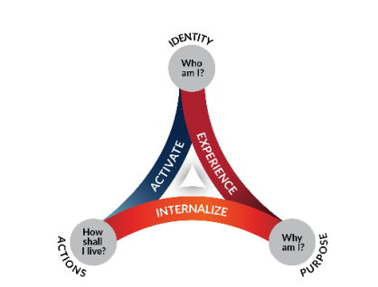
Lord, thank You for Your Word, which gives understanding and wisdom to us. Train us to search it with diligence and to show integrity in following what it says, for the Bible contains the words of life. Encourage us when we’re challenged by something we don’t understand. Help us to recognize when people make false claims and distort Your truth. We look to You and to Your instruction for our answers. In Jesus’ name, Amen.

