Growing Character Together: Insights for Parents

Week 7 | Respect
David and Absalom
BIG QUESTION
How can you respect God and others even when you are being treated unfairly?

VIRTUE
RESPECT: God’s power for you to honor Him and others.

HISTORICAL BACKGROUND
2 Samuel 14:1, 21-33; 15:1-30; 16: 5-15; 18:1-15, 32, 33

Our story takes place toward the end of King David’s reign over the people of Israel. David had several sons who had grown to be young men, but not men after God’s heart like David. One was named Amnon and the other Absalom. Because of a horrible sin Amnon committed, Absalom murdered him out of vengeful anger and then fled to a different country. David was so sad because one of his sons was now dead and the other a murderer; however, but David still loved Absalom. Even though Absalom was a murderer, David allowed him to come back to Israel and live a normal life. Absalom had no respect for his father, King David and planned to become king. Absalom won the hearts of the Israeli people by pretending to care about their disputes and telling them that he would be a fair judge unlike his father, King David. Eventually Absalom raises an army to fight against his father for the throne. David flees Jerusalem with his people, but during this extremely difficult time, David continues to respectfully worship and obey God and respect the people around him even his son who is trying to kill him!

Scripture: https://live.bible.is/bible/ENGNIV/2SA/14?audio_type=audio; https://live.bible.is/bible/ENGNIV/2SA/15?audio_type=audio; https://live.bible.is/bible/ENGNIV/2SA/16?audio_type=audio; https://live.bible.is/bible/ENGNIV/2SA/18?audio_type=audio

Experience It.
What if you had been in a situation like King David: Someone from your own family wanted to really hurt you - even kill you - even though you had been kind to that person? How do you think that would make you feel?
Hint: sad, scared, afraid, confused, misunderstood, angry.

Internalize It.
As King of Israel, David knew his ultimate purpose was to love and worship God with all his heart and help his people do the same. As we think about our Bible story, how do we see David accomplishing this purpose even though Absalom did not respect him?
Hint: David looked to God for what he should do instead of retaliating, David worshiped God and led his people to worship God even as they were being treated badly, he treated Absalom well and asked others to treat him well.

Activate It.
Is there someone in your life right now that you know you are not treating with respect? What is something you can do today that would show respect to that person?
Hint: Listen and obey, treat this person with kindness by saying kind words and doing kind things, try to understand this person’s point of view.

CHRIST CONNECTION
Like King David, Jesus was treated unfairly. Jesus never sinned, so he never deserved to be arrested, accused, mocked, beaten, humiliated, and killed. While all this was happening, Jesus continued to live in respect to his Heavenly Father, accepting and living out his plan. Jesus also showed humble respect to the people who were treating him horribly. He did not retaliate or sin in seeking revenge but forgave them and entrusted himself to God.

FAMILY MEMORY VERSE
“But if you suffer for doing good and you endure it, this is commendable before God. To this you were called because Christ suffered for you, leaving you an example that you should follow in his steps.” (1 Peter 2:20b-21)

PRAYER
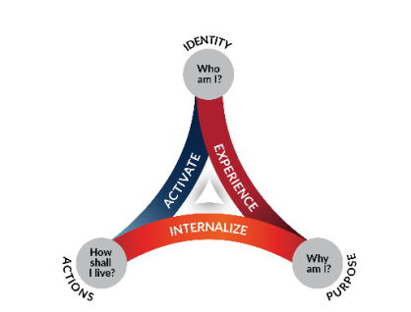
Lord God, Thank You so much for Your Word and this story of David and Absalom. Would You help me to remember this story when I am treated disrespectfully so that I could respond as David did and not Absalom. In Your name, Amen.

