Growing Character Together: Insights for Parents

Week 12 | Justice
Israel’s Kings Turn Away from God
BIG QUESTION
How can you respect God through the responsibilities He has given you?

VIRTUE
JUSTICE: God's power for you to honor Him and others.

HISTORICAL BACKGROUND
1 Kings 11:26-39, 12:25-33; 14:1-10a

The nation of Israel had been ruled by three kings thus far, Saul, David and Solomon. King David loved God, and although he wasn’t perfect, he was called a man after God’s own heart. God promised there would be a descendant of David forever on the throne. David’s son, Solomon, started his reign as king well, loving and obeying God; but he had many wives from countries that did not worship the one true God, and these wives turned Solomon’s heart away to worship idols and lead his people to do the same. God’s covenant, or promise, was clear in the Old Testament: He would bless Israel if they would love, worship and obey him. If they didn’t, he would bring trouble to them to remind them to worship God alone. This trouble came through God choosing to take the nation of Israel and divide it in two. Solomon’s son, Rehoboam, would rule the southern kingdom of Judah, but Jeroboam who was one of Solomon’s officials would rule the northern kingdom of Israel. In our Bible lesson, we see Jeroboam as a respected young man who did his work well, but once given reign of Israel, he did not obey and respect God in the responsibilities that God gave him.

Scripture: https://live.bible.is/bible/ENGNIV/1KI/11?audio_type=audio; https://live.bible.is/bible/ENGNIV/1KI/12?audio_type=audio; https://live.bible.is/bible/ENGNIV/1KI/14?audio_type=audio

Experience It.
Imagine that you are Jeroboam taking a walk on the way out of the city of Jerusalem when you are met by a prophet named Ahijah who you know speaks for God. He pulls off his cloak (a big, long coat) and starts to tear it up! He gives you ten pieces and tells you that you are going to rule as king over the ten northern tribes of Israel and King Solomon’s son is just going to rule over one. How do you think you would respond?
Hint: Maybe with surprise, why me? Maybe with humility and gratitude that God would choose me for such an important and big job, I would feel overwhelmed or fearful at the thought of being a king.
Internalize It.
God had given Jeroboam great purpose in his life to rule as king of Israel. With that purpose came the responsibility to worship and obey God and lead his people to do the same. Instead of God’s working towards God’s purpose, what did Jeroboam do?
Hint: When he became king, he didn’t look to God or his word for making decisions; he made decisions that he thought would benefit him. He built idols and shrines and altars to worship false Gods.

Activate It.
How can humble respect for God and his commands help you make decisions every day?
Hint: Instead of just thinking about what we want and making decisions based on how we feel, we can think about what God says and choose his ways and not ours.

CHRIST CONNECTION
Our story is a good example of how God interacted with his people in the Old Testament through what is called the Old Covenant or old promise. The people of Israel were a special people with special laws and special worship to the One True God. They were to be an example of what God is like to the people in the world around them and this could only happen when they worshipped and obeyed God as He told them to. The Old Covenant was a two-sided promise, God promised to bless and be with his people and his people promised to worship and obey Him. If they didn’t, God also promised to bring trouble to his people so that they would turn from their sin back to God.

The Old Covenant pointed to the new covenant in which forgiveness is found by grace, through faith in Jesus, not through obeying the law. In Luke 22:20 as Jesus is eating the Passover with his disciples right before he is crucified, he says, “This cup is the new covenant in my blood which is poured out for you.” Through the life, death and resurrection of Jesus, we become his people who are new creations with hearts that want to worship and obey Him.

FAMILY MEMORY VERSE
“God leads the humble in what is right and teaches the humble his way. All the paths of the Lord are steadfast love and faithfulness, for those who keep his covenant and his testimonies.” (Psalm 25:9-10)

PRAYER
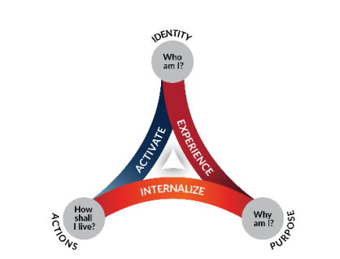
Lord Almighty, You are worthy of our worship and our lives. We want to show You respect by obeying your commands because we love You and You love us. Help us live our whole lives in loving respect for who You are and how You tell us to live. In Your holy name, Amen.

