Growing Character Together: Insights for Parents

Week 11 | Courage
Jehoshaphat Trusts God for Victory
BIG QUESTION
How can you trust, seek and follow the Lord in every situation especially when you are afraid?

VIRTUE
COURAGE: God’s power for you to overcome fear.

HISTORICAL BACKGROUND
2 Chronicles 20:1-30

Our story takes place about 3,000 years ago (850 BCE), during the time when a man named Jehoshaphat ruled as king of Judah in the city of Jerusalem. Like his father Asa, Jehoshaphat’s “heart was devoted to the ways of the Lord.” (2 Chronicles 17:6) We see that he loved and obeyed God’s word because he had officials and Levites teach it throughout Judah so that his people would also love and obey God (2 Chronicles 17:7-10). He also appointed judges who he encouraged to serve faithfully and wholeheartedly in the fear of the Lord. (2 Chronicles 19:4-11). Not only did Jehoshaphat lead the nation of Judah well, but, most importantly, Jehoshaphat wanted to trust, seek and follow the Lord. We see him do that as he faced the terrifying news that the nations bordering Judah to the east, Ammon and Moab, were coming to wage war against him with larger armies than Judah had. He courageously turns to God for help and answers.

Scripture: https://live.bible.is/bible/ENGNIV/2CH/20?audio_type=audio

Experience It.
Imagine you are King Jehoshaphat, and while you are relaxing in your palace, a group of men rush in with panic on their faces to tell you that a huge army is coming to destroy you, your family, and all the people in your kingdom! You know that your army isn’t big enough to slow your enemy down or stop them. How do you think you would feel?
Hint: Afraid, helpless, panicked, responsible, alarmed, sad

Internalize It.
How could God use you to lead others to courageously trust God in difficult circumstances?
Hint: Be an example of trusting God, pray with them, share Bible memory verses, tell stories about how God has been faithful to me in the past or share Bible stories of God’s faithfulness.

Activate It.
Have you ever been in a situation where someone helped you to trust, seek and follow God courageously in a difficult situation? What was it like?
Hint: Answers will vary.

CHRIST CONNECTION
The Old Testament provides many examples of people and circumstances that point to the Gospel and Jesus Christ. When God first brought the Israelites into the Promised Land, He ruled as their perfect king. The people, however, wanted a human king to rule them, and God gave them their request. For approximately 500 years, God’s people were ruled by both godly and evil kings, leading the hearts of the people either towards or away from God. One such godly king was David, a man after God’s own heart. God promised King David that one of his descendants would reign over God’s people forever; that promised descendant was Jesus. He was born and crucified as the King of the Jews but reigns forever as Lord of Lords and King of Kings. (Revelation 17:14)

FAMILY MEMORY VERSE
“When I am afraid, I put my trust in you. In God, whose word I praise - in God I trust and am not afraid.” (Psalm 56:3-4)

PRAYER
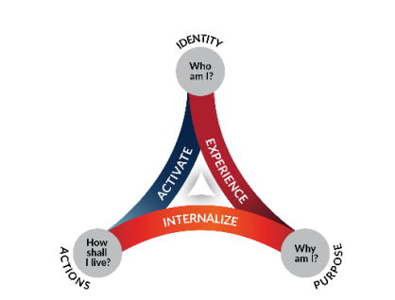
Lord of all creation, thank You so much for the awesome story of Jehoshaphat and his example of faith-filled courage and the ways that he loved You. Please help me to trust, seek and follow You as Jehoshaphat did when I am afraid. In Your powerful name, Amen.

